PROJECT TITLE

# CREDIT CARD PROCESS SYSTEM

Submitted in partial fulfilment of the requirement of

PG Diploma in Advanced Computing

By

Rani Ramdayal Shukla - 220940520071

Ravi Kumar - 220940520072

Robin Alex Oommen - 220940520073

Rohit Sadashiv Bhosale - 220940520074

Sachin Shivaji Bondre - 220940520075

Sagar Hindurao Bhutal - 220940520076

Sagar Kalankar - 220940520077

Sagar Natthu Patil - 220940520078

Sagar Rajendra Kamble - 220940520079

Sagar Rajendra Sonar - 220940520080

Guide(s):

Miss. Shweta Bhere



Centre for Development of Advanced Computing

Juhu

Sept 2022

**Abstract**

The emergence of e-commerce has created new financial needs that in many cases cannot be effectively fulfilled by the traditional payment systems. Recognizing this, virtually all interested parties are exploring various types of electronic payment system and issues surrounding electronic payment system and digital currency. Broadly electronic payment systems can be classified into four categories: Online Credit Card Payment System, Online Electronic Cash System, Electronic Cheque System and Smart Cards based Electronic Payment System. Each payment system has its advantages and disadvantages for the customers and merchants. These payment systems have numbers of requirements: e.g. security, acceptability, convenience, cost, anonymity, control, and traceability.Therefore, instead of focusing on the technological specifications of various electronic payment systems, the researcher have distinguished electronic payment systems based on what is being transmitted over the network; and analyse the difference of each electronic payment system by evaluating their requirements, characteristics and assess the applicability of each system. The trend shows that more and more Indonesians do financial transactions electronically via banks ATMs, internet banking and SMS-banking.

Here we are exploring use of Credit Card Processing system and its SRS.

**Contents**

|  |  |  |
| --- | --- | --- |
| **Chapter** | **Contents** | **Page No.** |
| 1 | INTRODUCTION |  |
| 2 | ANALYSIS MODELING |  |
|  | 2.1 Use Case Diagram  2.2 Class Diagram  2.3 Activity Diagram  2.4 Sequence Diagram |  |
| 3 | DESIGN |  |
|  | 3.1 ER Diagram |  |

**List Of Figures**

|  |  |  |
| --- | --- | --- |
| **Fig No** | **Title** | **Page No.** |
| 1 | Use Case Diagram |  |
| 2 | Class Diagram |  |
| 3 | Activity Diagram |  |
| 4.1 | Sequence Diagram |  |
| 4.2 | Sequence Diagram |  |
| 5 | ER Diagram |  |

**Chapter No 01**

**Introduction**

A **credit card** is a small plastic pvc card issued to users as a system of payment. It allows its holder to buy goods and services based on the holder's promise to pay for these goods and services. The issuer of the card creates a revolving account and grants a line of credit to the consumer (or the user) from which the user can borrow money for payment to a merchant or as a cash advance to the user.

When a purchase is made the merchant swipes the card. The information goes to a gateway processor, which either accepts or rejects the transaction. If it is accepted, the transaction is held until the end of the business day. The merchant then reenters the transaction via the gateway processor, the data is logged, and the debt is transferred to the account. The use of an ATM for cash advance is a similar process.

If you are selling to consumers, merchant services will allow you to expand your customer base and provide a more convenient method of payment than cash or checks. And if you are interested in selling over the Internet, accepting credit card processing is a must. Accepting credit cards allows funds to be transferred to your bank account in less than a week. This can be a welcome relief for businesses that experience a tight cash flow.

The two purchase options for Credit Card Processing facility are:

* Validation only
* Credit card processing (which secures deposits at the time of booking)

With either option, credit card accounts entered during booking are validated to assure that the account is active and in good standing. The credit card processing option also allows properties to process credit card deposits.

**Chapter No 02**

**Analysis of Modeling**

1. **USE CASE DIAGRAM**

Credit Card system use below cases:

***ENTITY (CLASS) INVOLVED:-***

**Customer/user:** The person who order for the item.

**Banker:** The person to check the account details.

**Retailer:** The person to preparing the bills.

***Methods & variables-***

**Creating Account:** to create a account.

**Credit card request:** to send the request to credit card.

**Bank Enquiry:** Used to get the bank enquiry like pin code to verify your user account.

**Issuing card:** Used to issuing the card to user.

**Purchase the item:** Used to list out the purchase details in shop.

**Prepare the bill:** Used to issuing the bill for the purchased item.

**paying bill:** Used to transaction of money to paying the bill.

**USE-CASE NAME: PURCHASE PRODUCT-**

Customer purchases items from ecommerce site or Retailer Shop then proceeds to the site’s secure checkout area.

**USE-CASE NAME: AUTHORIZATION REQUEST-**

Credit card processor collects billing information from the retailer via a secure connection.

**USE-CASE NAME: AUTHORIZATION RESPONSE-**

Billing information is verified using PIN/OTP and the transaction is completed by the credit card issuer.

**USE-CASE NAME: PAYMENT APPROVAL-**

The transaction details are recorded by the credit card processor and results are securely relayed to the merchant. Merchant’s site receives transaction result and does appropriate actions (e.g. saves the order details & shows message).



creating account

credit card request

bankenquiry

banker

issuing card

customer

purchase the item

prepare the bill

retailer

1. **USE CASE DIAGRAM**
2. **CLASS DIAGRAM:**

The class diagram, also referred to as object modeling is the main static analysis diagram. The main task of object modeling is to graphically show what each object will do in the problem domain. The problem domain describes the structure and the relationships among objects.

The Credit Card Processing system class diagram consists of three classes. They are

* 1. Banker
  2. Customer
  3. Retailer



1. Class Diagram



Start

[ new account]

customer

creating account

do/ creating account

Exiting account

Request To Bank

[ Customer Enquiry ]

requesting for credit card

Bank Processing

enquiry from bank

do/ requesting credit card do/ bank enquiry

[ Satisfied Customer ]

abort

issuing card

do/ card delivery

*End*

1. Activity Diagram

1: Select Bank

2: Creating Account

3: Requesting Card

4: Enquiry

5: Issuind Card

6: select shop

7: Purchase Item

8: producing item for billing

9: preparing bills

10: Swipe the card

11: validate card

12: Paying the bills

13: returning amount

14: checking account details

R:Retailer

4.1 Sequence Diagram

6: select shop

7: Purchase Item 09: Preparing Bill

12: Paying the bills

5: Issuind Card

1: Select Bank

2: Creating Account

3: Requesting Card

13: returning amount

14: checking account details

4: Enquiry

11: validate card

R:Retail

er

C:Customer

mer

B:Banker

r

8: producing item for billing

10: Swipe the card

4.2 Sequence Diagram

Chapter 3

ER Diagram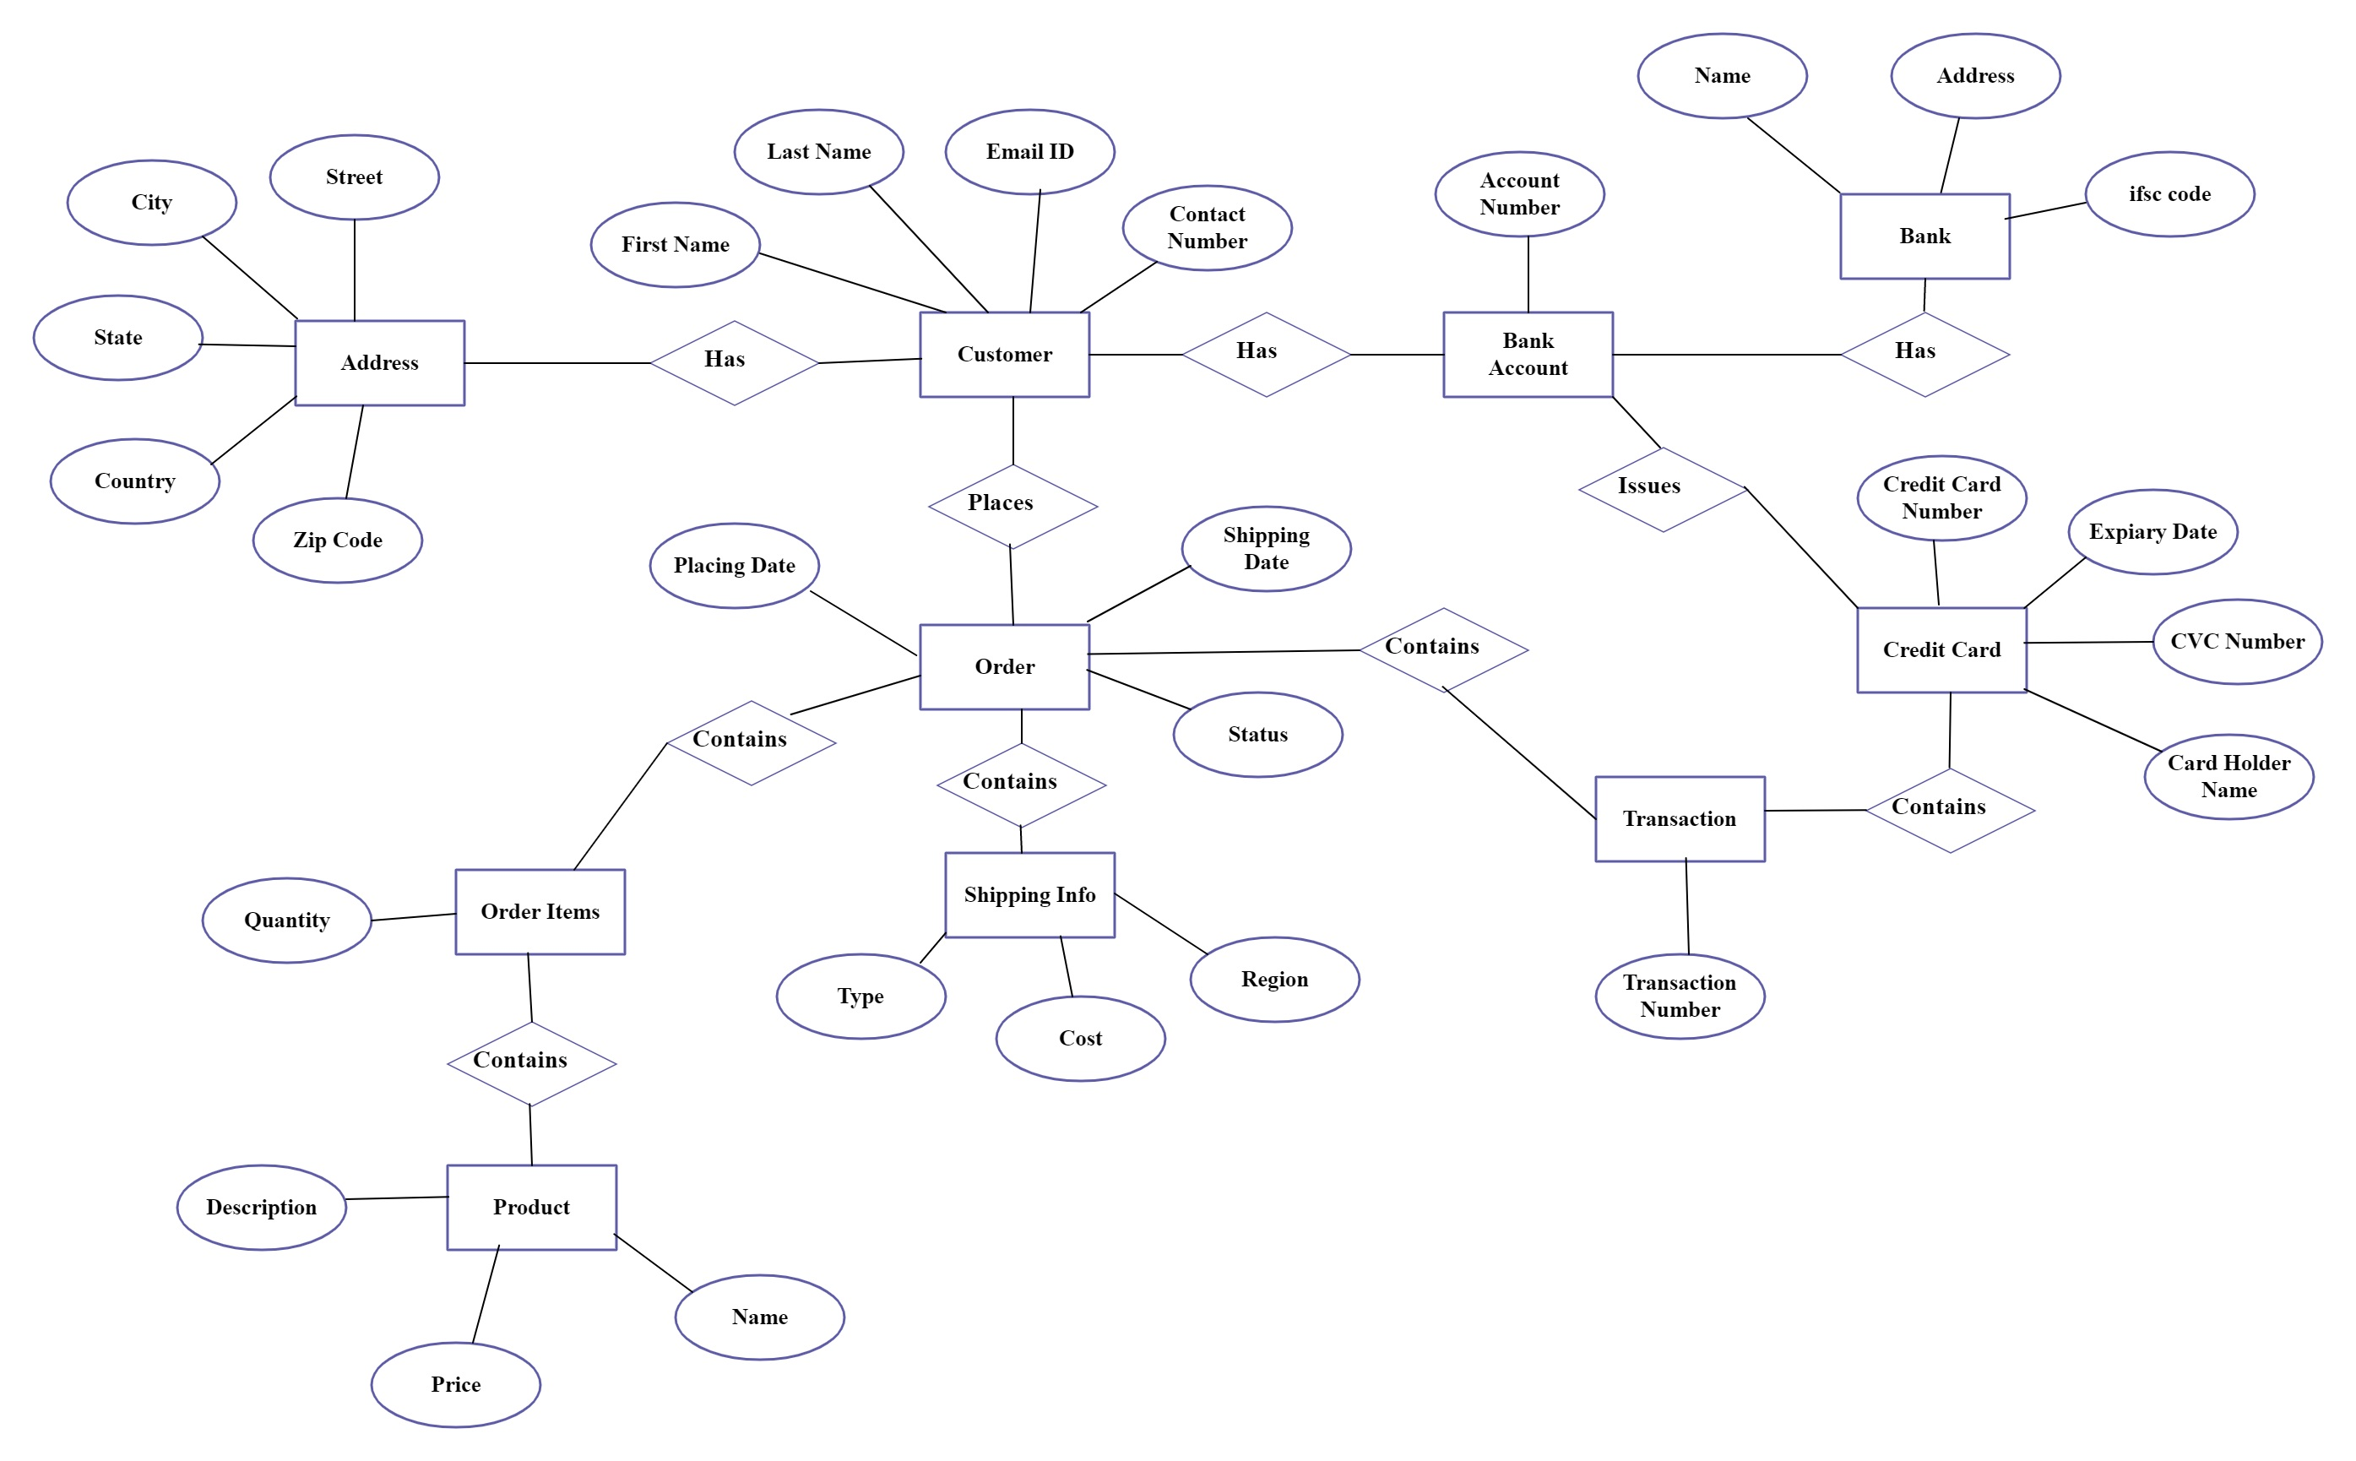

5. ER Diagram